Froedtert & the Medical College of Wisconsin
Forest Home Health Center
Location: 1316 W Forest Home Avenue, Milwaukee WI 53204
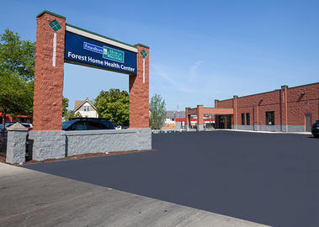
On the corner of 13th Street, Forest Home, and Mitchell. Entrance is located across the parking lot from Dominos Pizza.
Bus stops nearby:
19 Line: Corner of S 11th Street & Mitchell
20 Line: Corner of Forest Home & S 13th Street
54 Line: Corner of Mitchell & S 11th Street

General Clinic Phone: 414-424-5000

CARE Program Nurse: 414-424-5053

Clinic Hours
Sunday | Monday | Tuesday | Wednesday | Thursday | Friday | Saturday
Closed | 8:00 am -5:00 pm | 8:00 am – 6:00 pm | 8:00 am – 6:00 pm | 8:00 am -5:00 pm | 8:00 am -5:00 pm | Closed

Services Available
- Comprehensive Primary Care / Family Medicine
  - Hep C treatment
  - Musculoskeletal Care- including injections, treatment of common injuries, and osteopathic manipulation
  - Pregnancy Services / Obstetrics
  - Pediatrics
  - Substance Use Treatment & Support
  - STD/STI treatment
  - Refugee Care
- Behavioral Health Counseling
- Laboratory
- Social Work and Nurse Case Management
- Bilingual Spanish Speaking staff and access to interpreters

Please Note: The Forest Home Clinic does NOT provide methadone treatment for substance use disorders

Froedtert & the Medical College of Wisconsin
Comprehensive Assisted Recovery and Empowerment (CARE) Program

Our goal at the Froedtert Forest Home Health Center is to care for the whole person. That includes partnering with patients to identify and understand their unique needs. Through a team-based model called the Comprehensive Assisted Recovery and Empowerment (CARE) Program, patients can have direct access to mental health services and treatment for substance use disorders at their primary care clinic.
What makes CARE special?
CARE is truly patient centered. The dedicated CARE team works with patients, giving patients the skills they need to set and reach their self-care goals. The CARE Program helps patients get better faster, while allowing patients to decide what they want work on. Research shows that this model is the best way to help those with mental health concerns, substance use disorders, and/or complex social needs achieve their physical and mental health goals and feel better faster.
How does CARE work?
Clinicians use motivational interviewing to help patients identify and achieve their health goals. The patient and the CARE team decide together how to best treat their condition. Treatment can include medicine, lifestyle changes or counseling. If the first plan does not work, the team will help patients make changes. It is very common for patients to change their plan at least once. The team is there to support them and help patients find the best plan for them. Our goal is to help improve the symptoms that bother patients the most by at least 50% within 10-12 weeks.
The Comprehensive Assisted Recovery & Empowerment (CARE) team includes:
- You - the patient
- Your Primary Care Provider
- Nurse Case Manager – an experienced nurse who works closely with you to help achieve your goals.
- Team Psychologist – a Behavioral Health Clinician
- Team Psychiatrist – the psychiatrist helps the primary care doctor and Behavioral Health Clinician to make sure your symptoms are improving.
- Team Social Worker – an experienced social worker who can help you find and access needed resources.
- Peer Support Specialists – an individual with lived experience with addiction and recovery who provides non-clinical support to people who are seeking recovery assistance.
Each CARE patient is assigned a nurse case manager, who works directly with the patient, physician, and team psychiatrist to help manage the patient’s care. The nurse case manager will call patient’s every 1-4 weeks to check in and see how they are feeling. Patients may also meet with the nurse in person on a routine basis.
Is there a cost?
There is no direct cost to the patient. We bill patients’ insurance coverage for these services. Collaborative Care services are typically covered by most insurance plans and patients can choose to disenroll or stop services anytime.

Direct Referral Process for the
Forest Home Health Center CARE Program
- What is the need?
  - Such as: general health care, HIV testing/treatment, substance use treatment (not methadone), pregnancy, behavioral health counseling, etc., refer to Forest Home Health Center.
  - If seeking methadone treatment, refer to Community Medical Services
- Do they have health insurance coverage?
  - YES:
    - The Forest Home Clinic accepts most health insurance plans, except
      - Molina Medicaid- refer to another location or direct to insurance navigator for assistance with changing health plan.
  - NO Insurance / Undocumented: Refer to a local safety next clinic such as:
    - Sixteenth Street Community Health Centers (* offers substance use treatment)
    - Aurora Walker’s Point Clinic
    - Ascension Saturday Clinic for the Uninsured
    - Bread of Healing Free Clinic
    - Progressive Community Health Center
  - UNSURE:
    - Refer to CARE nurse case manager.
- Set expectations for communication with/from Forest Home Clinic.
  - This is not for emergent needs.
  - Someone will reach out to you in the next few days during normal business hours to help you schedule an appointment to see a doctor.
- Obtain:
  - First & last name
  - Phone number
  - Preferred method of communication:
    - Phone call
    - Text message.
  - Preferred time for contact during business hours (8-5)?
- Complete Street Life QR code.

ADDITIONAL RESOURCES

If someone is experiencing a crisis, please dial 911 or go to the nearest emergency room.
- 988 SUICIDE & CRISIS LIFELINE Wisconsin: Call/Text/Chat
  - Call/Text: 988
  - Website: www.988lifeline.org
- NEVER USE ALONE: Call/Chat
  - Call 1-877-696-1996
    - Spanish Line: 1 (800) 928-5330
  - Chat on Website: https://neverusealone.com/
- SAFER SUBSTANCE USE
  - Website: https://safersubstanceuse.org/

HOUSING SUPPORT:
- Call Impact 211 (dial 211) or
- Visit Community Advocates - communityadvocates.net
  - 728 N James Lovell St, Milwaukee, WI 53233
  - Phone: (414) 449-4777

INSURANCE ENROLLMENT HELP: https://coveringwi.org/enroll#Appointment

FAQs for opioid and alcohol use treatment options:
- How long until I will feel better?
  - It will take approximately 1-2 months for patients to begin feeling better after starting treatment.

- What medications are used to treat substance use disorders?
  - Buprenorphine (Suboxone®, Subutex®, Zubsolv®, Sublocade®)
    - Buprenorphine is available as a dissolving tablet, cheek film, or monthly injection.
    - Health care professionals prescribe the at-home doses (tablet or film) or administer the injection in an office setting.
  - Methadone:
    - Methadone is available as a daily liquid. Patients take it at a certified opioid treatment program.
    - Local Methadone Treatment Centers
      - Community Medical Services
      - Comprehensive Treatment Centers
  - Naltrexone (Vivitrol®):
    - Naltrexone is available as a monthly injection for alcohol use disorder or opioid use disorder.
    - There is a higher risk of opioid overdose with Naltrexone due to the medication reducing opioid tolerance level.

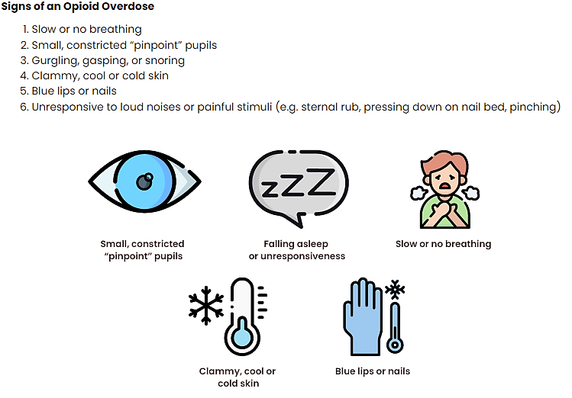
- Good Samaritan Laws (provide immunity) protect people who call 911 for emergency medical services and/or administer naloxone in an overdose situation from arrest for possession of drugs and/or paraphernalia. It does not provide legal protection for individuals on parole, probation, or other community supervision violations. https://nextdistro.org/wi-goodsamaritan

NARCAN (NALOXONE) NASAL SPRAY
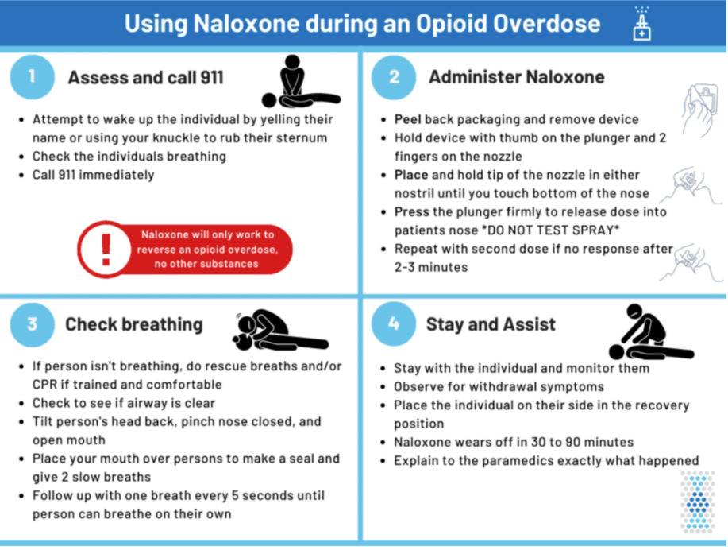
FENTANYL TEST STRIPS
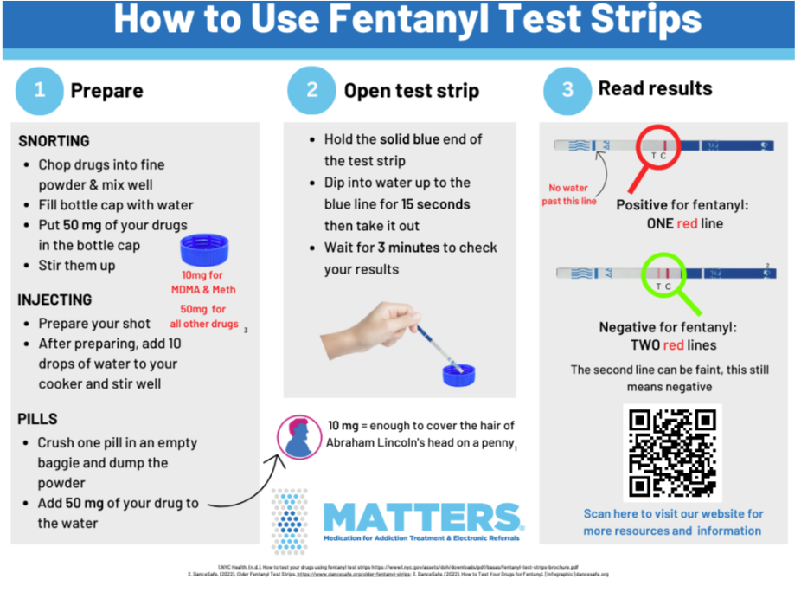
Fentanyl Test Strip FAQs
- What is Fentanyl?
  - Fentanyl is a white powdery substance. It can be found in heroin, cocaine, benzodiazapines, pills, methamphetamines, and other drugs. Fentanyl causes overdoses because it is 50x stronger than heroin and 100x stronger than morphine.
- The test strips say they are for urine, can I still use them to test substances?
  - Yes! The test strips were originally designed to test urine and are now also used to test substances for fentanyl.
- What are the test strip limitations?
  - Test strips are only able to test for the presence of Fentanyl, not the potency (how strong) or the amount (how much) of the substance is present.
- Do Fentanyl test strips check for Fentanyl analogs (acetylfentanyl, butyrfentanyl, carfentanil, alfentanil, sufentanil, and remifentanil)?
  - Fentanyl test strips can detect most, but not all fentanyl analogs. Just because a test strip comes back negative, does not guarantee there is no Fentanyl in the product.
- What is the chocolate chip cookie effect?
  - Fentanyl clumps together, instead of being evenly distributed, when it is mixed into powders or pressed pills. Similar to chocolate chips in a cookie. This means that the portion of the pressed pill or powder you test may be negative, even though other parts of the sample contain Fentanyl.
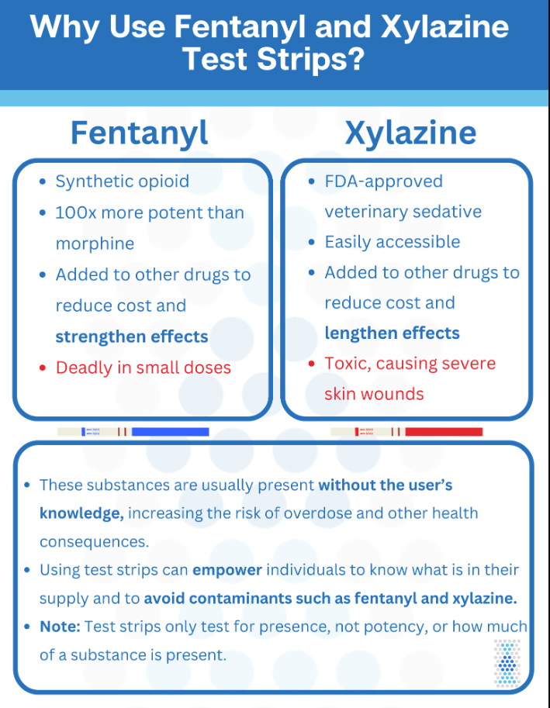
https://mattersnetwork.org/wp-content/uploads/2023/10/Why-use-TS.png

